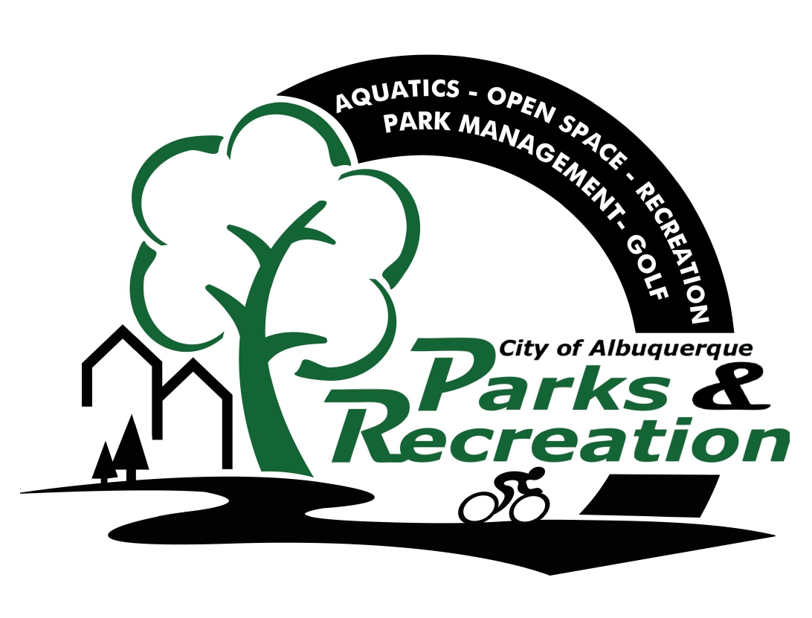
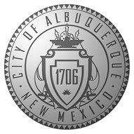
CITY OF ALBUQUERQUE
PARKS & RECREATION
2014 SEASONAL INDOOR TRACK
YOUTH PERMISSION/LIABILITY RELEASE FORM

I am the parent or legal guardian of the child named below and give my permission for him/her to participate in the Indoor Track located at the Albuquerque Convention Center. I understand my child may need appropriate clothing, supplies or may need to pay a fee. For and in consideration of the City of Albuquerque, Parks & Recreation Department allowing my child_____________________ to attend and participate in the Indoor Track facility. I hereby consent and agree to the following:

CONSENT OF TREATMENT
In the event that my child should, for any reason require any medical or surgical treatment and/or medication during the course of his/her attendance or participation in the Indoor Track facility, I authorize such physicians or medical staff as the organizers of this activity may appoint or designate to carry out the necessary treatment, or to take my child/ward to the emergency room of the nearest hospital, and I further authorize the hospital and its medical staff to provide treatments deemed necessary by them for the well being of my child/ward. It is understood, however, that if hospitalization or treatment of a more serious nature is required, I will be contacted, if at all possible by telephone for permission. __________ Initial

MEDIA
I hereby grant permission for the employees of the Indoor Track facility to record my child’s likeness for use by television, film, radio or printed media to further the aims of those activities and programs in related campaigns, magazine articles, booklets, posters, and in any other ways they may see fit. I hereby release them from any and all claims in its usage. __________ Initial

LIABILITY
I covenant that I have taken such measures as I have deemed advisable to ascertain that my child’s physical
condition is suitable for the program (including a doctor’s physical, if appropriate). I also confirm that my child is covered by a medical insurance policy and that I will either pay any medical bills arising out of an injury suffered by my child during the program or make a claim for our medical insurance to pay same and that neither I nor my child/ward will seek to hold the City of Albuquerque, Indoor Track facility nor the above entities; directors, employees, volunteers, and agents liable for medical expenses. In consideration of the City of Albuquerque, allowing my child to participate in the program, I hereby forever release, discharge and hold harmless the City of Albuquerque, staff and volunteers associated with the Indoor Track facility from any and all claims, demands, damages, lawsuits, expenses or charges [of] whatsoever kind which may hereafter accrue or result from any injuries whatsoever, from our participation or our child’s participation in the City of Albuquerque, Indoor Track facility. __________ Initial

INFORMATION RELEASE
I give consent to my child’s school district/agency to release to the Indoor Track facility the following information concerning my child: child’s age, exceptional/special needs, and child’s special restriction limitations. I understand this information will only be used by the Indoor Track facility staff to plan appropriate activities for the Indoor Track facility. __________ Initial

This signature applies to all of the above:

Signed_____________________________________________________ Date: ________________________

Relationship: __________________________________________________________

